SIMATS ENGINEERING
ASSESSMENT TOOL 3

COURSE NAME: OPERATING SYSTEMS COURSE CODE: CSA04

COURSE OUTCOME COVERED
CO2: Analyze process management and deadlock handling techniques to improve CPU utilization and system performance(BL3-BL4

Assessment Tool Weightage: 30%

QUESTIONS: 10 Total Marks:50

Annexure A
Debugging or Optimization task

Code of Conduct:
I Sruthi Rithika P (192521407)(Name / Reg No) certify that this submission is my original work and that I have adhered to the guidelines specified for this assessment.
I understand that any violation of academic integrity rules will result in disciplinary action.

Signature of the student: Sruthi Rithika P

Q1. Deadlock Debugging (Code Trace)
#include <stdio.h>
int main()
{
int R1 = 0, R2 = 0;
printf("===== DEADLOCK SIMULATION =====\n\n");
printf("Process P1 locks Resource R1\n");
R1 = 1;
printf("Process P2 locks Resource R2\n");
R2 = 1;
printf("Process P1 requests Resource R2...\n");
if (R2 == 1)
printf("P1 is Waiting for R2\n");
printf("Process P2 requests Resource R1...\n");
if (R1 == 1)
printf("P2 is Waiting for R1\n");
printf("\nDeadlock Detected!\n");
printf("\n===== OPTIMIZED SOLUTION =====\n\n");
R1 = 0;
R2 = 0;
printf("Both processes acquire resources in the same order.\n\n");
printf("P1 locks R1\n");
R1 = 1;
printf("P1 locks R2\n");
R2 = 1;
printf("P1 enters Critical Section\n");
R2 = 0;
R1 = 0;
printf("P1 releases R2\n");
printf("P1 releases R1\n\n");
printf("P2 locks R1\n");
R1 = 1;
printf("P2 locks R2\n");
R2 = 1;
printf("P2 enters Critical Section\n");
R2 = 0;
R1 = 0;
printf("P2 releases R2\n");
printf("P2 releases R1\n");
printf("\nDeadlock Eliminated Successfully.\n");
return 0;
}
OUTPUT:
===== DEADLOCK SIMULATION =====

Process P1 locks Resource R1
Process P2 locks Resource R2
Process P1 requests Resource R2...
P1 is Waiting for R2
Process P2 requests Resource R1...
P2 is Waiting for R1

Deadlock Detected!

===== OPTIMIZED SOLUTION =====

Both processes acquire resources in the same order.

P1 locks R1
P1 locks R2
P1 enters Critical Section
P1 releases R2
P1 releases R1

P2 locks R1
P2 locks R2
P2 enters Critical Section
P2 releases R2
P2 releases R1

Deadlock Eliminated Successfully.

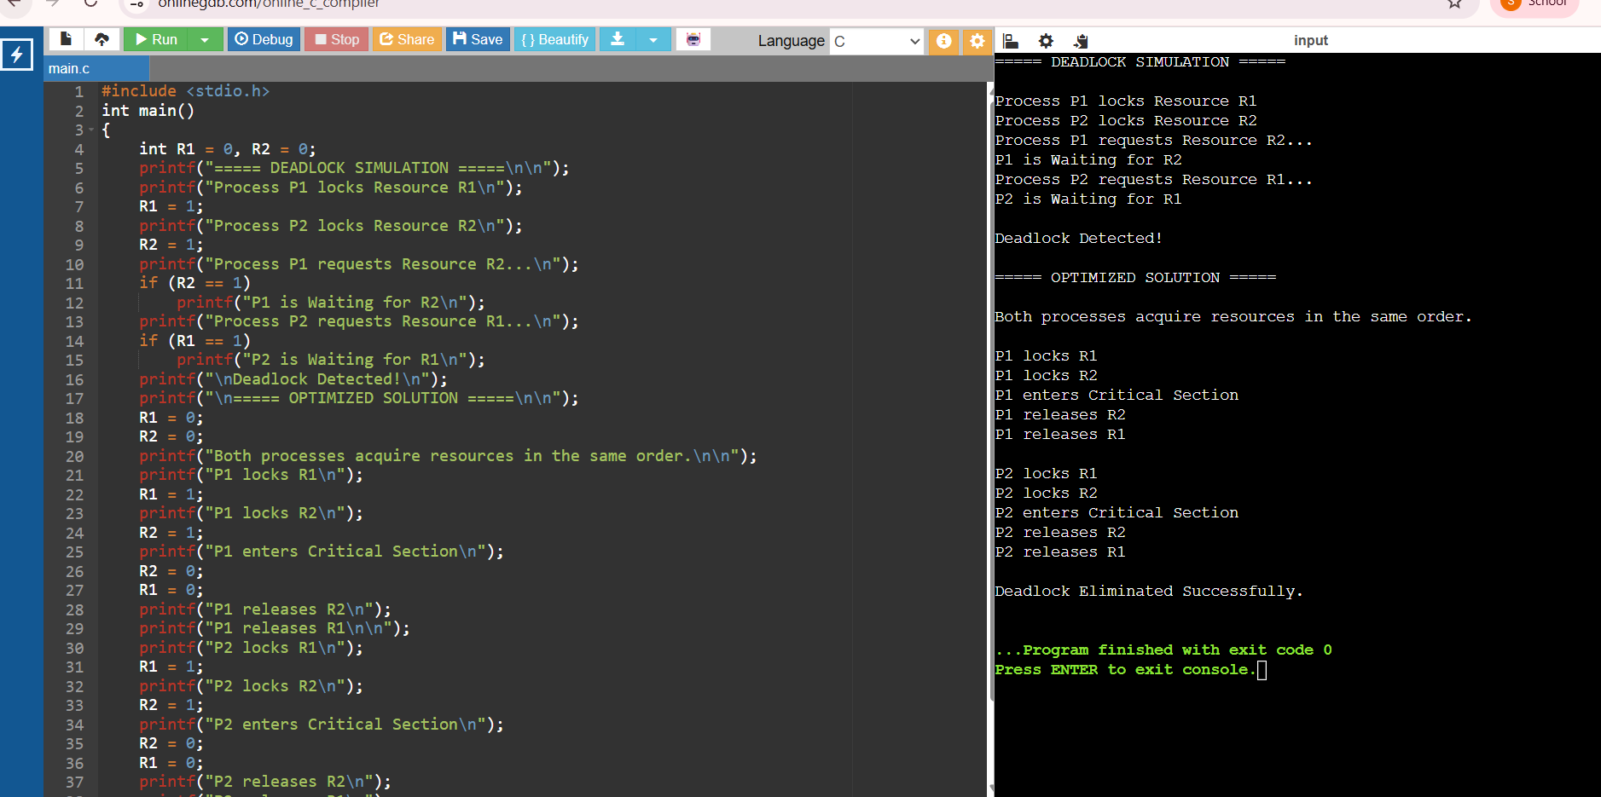

Q2. CPU Utilisation Problem
#include <stdio.h>
int main()
{
int n, i;
int cpuBurst[20], ioWait[20];
int totalCPU = 0, totalIO = 0;
float utilization_before, utilization_after;
printf("CPU Utilisation Simulation\n");
printf("--------------------------\n");
printf("Enter the number of processes: ");
scanf("%d", &n);
for(i = 0; i < n; i++)
{
printf("\nProcess P%d\n", i + 1);
printf("Enter CPU Burst Time (ms): ");
scanf("%d", &cpuBurst[i]);
printf("Enter I/O Waiting Time (ms): ");
scanf("%d", &ioWait[i]);
totalCPU += cpuBurst[i];
totalIO += ioWait[i];
}
utilization_before = ((float)totalCPU /
(totalCPU + totalIO)) * 100;
printf("\n========== BEFORE OPTIMIZATION ==========\n");
printf("Total CPU Time : %d ms\n", totalCPU);
printf("Total I/O Wait Time : %d ms\n", totalIO);
printf("CPU Utilisation : %.2f%%\n", utilization_before);
printf("\nReason:\n");
printf("Processes frequently move to Waiting state due to I/O.\n");
totalIO = totalIO / 2;
utilization_after = ((float)totalCPU /
(totalCPU + totalIO)) * 100;
printf("\n========== AFTER OPTIMIZATION ==========\n");
printf("Reduced I/O Wait Time : %d ms\n", totalIO);
printf("CPU Utilisation : %.2f%%\n", utilization_after);
printf("\nOptimization Applied:\n");
printf("1. Faster I/O Devices\n");
printf("2. Asynchronous I/O / Increased Multiprogramming\n");
return 0;
}
OUTPUT:
CPU Utilisation Simulation
--------------------------
Enter the number of processes: 3

Process P1
Enter CPU Burst Time (ms): 10
Enter I/O Waiting Time (ms): 20

Process P2
Enter CPU Burst Time (ms): 30
Enter I/O Waiting Time (ms): 40

Process P3
Enter CPU Burst Time (ms): 25
Enter I/O Waiting Time (ms): 35

========== BEFORE OPTIMIZATION ==========
Total CPU Time : 65 ms
Total I/O Wait Time : 95 ms
CPU Utilisation : 40.62%
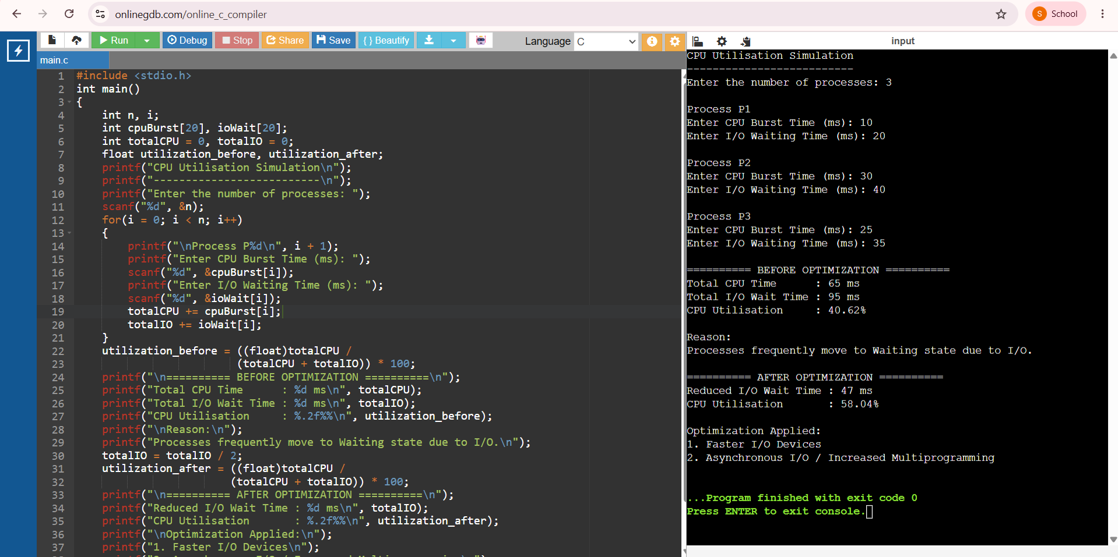

Q3. Memory Bottleneck Debugging
#include <stdio.h>
int main()
{
int codeSize = 5;
int heapSize = 150;
int stackPerThread = 1;
int threads = 25;
int ram = 2048;
int totalMemory, optimizedMemory;
int optimizedThreads = 10;
int optimizedHeap = 100;
printf("========== MEMORY BOTTLENECK DEBUGGING ==========\n\n");
printf("Memory Map\n");
printf("----------\n");
printf("Code Size : %d MB\n", codeSize);
printf("Heap Size : %d MB\n", heapSize);
printf("Stack Per Thread : %d MB\n", stackPerThread);
printf("Number of Threads : %d\n", threads);
printf("Physical RAM : %d MB\n", ram);
totalMemory = codeSize + heapSize + (threads * stackPerThread);
printf("\nTotal Memory Used : %d MB\n", totalMemory);
if(totalMemory < ram)
{
printf("\nPhysical memory is sufficient.\n");
printf("However, many threads access memory simultaneously.\n");
printf("This causes frequent page faults and performance degradation.\n");
}
else
{
printf("\nMemory exceeds RAM.\n");
printf("Heavy page faults will occur.\n");
}
printf("\n========== OPTIMIZATION ==========\n");
optimizedMemory = codeSize + optimizedHeap +
(optimizedThreads * stackPerThread);
printf("\nOptimization 1 : Reduce Heap Usage\n");
printf("Heap Reduced To : %d MB\n", optimizedHeap);
printf("\nOptimization 2 : Use Thread Pool\n");
printf("Threads Reduced To : %d\n", optimizedThreads);
printf("\nOptimized Memory Usage : %d MB\n", optimizedMemory);
printf("\nPerformance Improved");
printf("\nPage Faults Reduced");
printf("\nMemory Access Faster");
return 0;
}
OUTPUT:
========== MEMORY BOTTLENECK DEBUGGING ==========

Memory Map
----------
Code Size : 5 MB
Heap Size : 150 MB
Stack Per Thread : 1 MB
Number of Threads : 25
Physical RAM : 2048 MB

Total Memory Used : 180 MB

Physical memory is sufficient.
However, many threads access memory simultaneously.
This causes frequent page faults and performance degradation.

========== OPTIMIZATION ==========

Optimization 1 : Reduce Heap Usage
Heap Reduced To : 100 MB

Optimization 2 : Use Thread Pool
Threads Reduced To : 10

Optimized Memory Usage : 115 MB

Performance Improved
Page Faults Reduced
Memory Access Faster
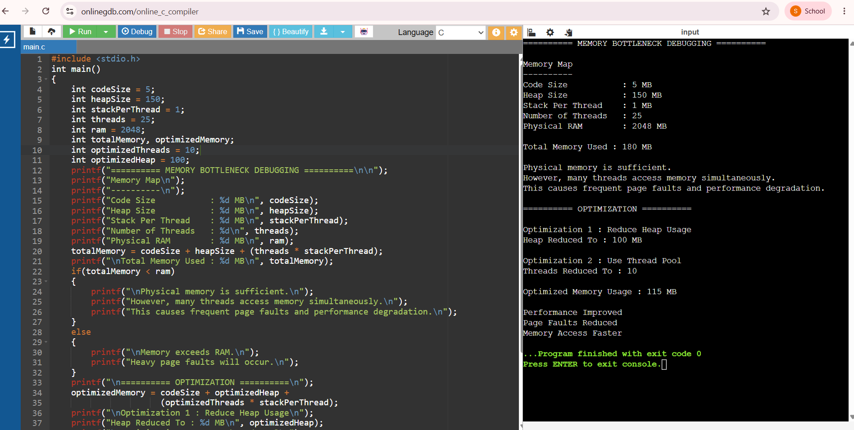
Q4. Starvation Debugging
#include <stdio.h>
#define MAX 10
struct Process
{
int pid;
int queue;
int burst;
int waiting;
int completed;
};
int main()
{
struct Process p[MAX];
int n = 5;
p[0] = (struct Process){1,1,3,0,0};
p[1] = (struct Process){2,1,2,0,0};
p[2] = (struct Process){3,2,4,0,0};
p[3] = (struct Process){4,1,3,0,0};
p[4] = (struct Process){5,3,5,0,0};
int completed = 0;
int cycle = 1;
printf("\n===== MULTILEVEL QUEUE SCHEDULER =====\n");
while(completed < n)
{
printf("\nScheduling Cycle %d\n", cycle);
int executed = 0;
for(int i=0;i<n;i++)
{
if(!p[i].completed && p[i].queue==1)
{
printf("Executing P%d from Q1\n",p[i].pid);
p[i].completed=1;
completed++;
executed=1;
break;
}
}
if(!executed)
{
for(int i=0;i<n;i++)
{
if(!p[i].completed && p[i].queue==2)
{
printf("Executing P%d from Q2\n",p[i].pid);
p[i].completed=1;
completed++;
executed=1;
break;
}
}
}
if(!executed)
{
for(int i=0;i<n;i++)
{
if(!p[i].completed && p[i].queue==3)
{
printf("Executing P%d from Q3\n",p[i].pid);
p[i].completed=1;
completed++;
executed=1;
break;
}
}
}
for(int i=0;i<n;i++)
{
if(!p[i].completed)
{
p[i].waiting++;
if(p[i].queue==3 && p[i].waiting>=3)
{
printf("Aging Applied -> P%d moved Q3 -> Q2\n",p[i].pid);
p[i].queue=2;
}
if(p[i].queue==2 && p[i].waiting>=5)
{
printf("Aging Applied -> P%d moved Q2 -> Q1\n",p[i].pid);
p[i].queue=1;
}
}
}
cycle++;
}
printf("\nAll Processes Executed Successfully.\n");
printf("Starvation Eliminated Using Aging.\n");
return 0;
}
OUTPUT:

===== MULTILEVEL QUEUE SCHEDULER =====

Scheduling Cycle 1
Executing P1 from Q1

Scheduling Cycle 2
Executing P2 from Q1

Scheduling Cycle 3
Executing P4 from Q1
Aging Applied -> P5 moved Q3 -> Q2

Scheduling Cycle 4
Executing P3 from Q2

Scheduling Cycle 5
Executing P5 from Q2

All Processes Executed Successfully.
Starvation Eliminated Using Aging.
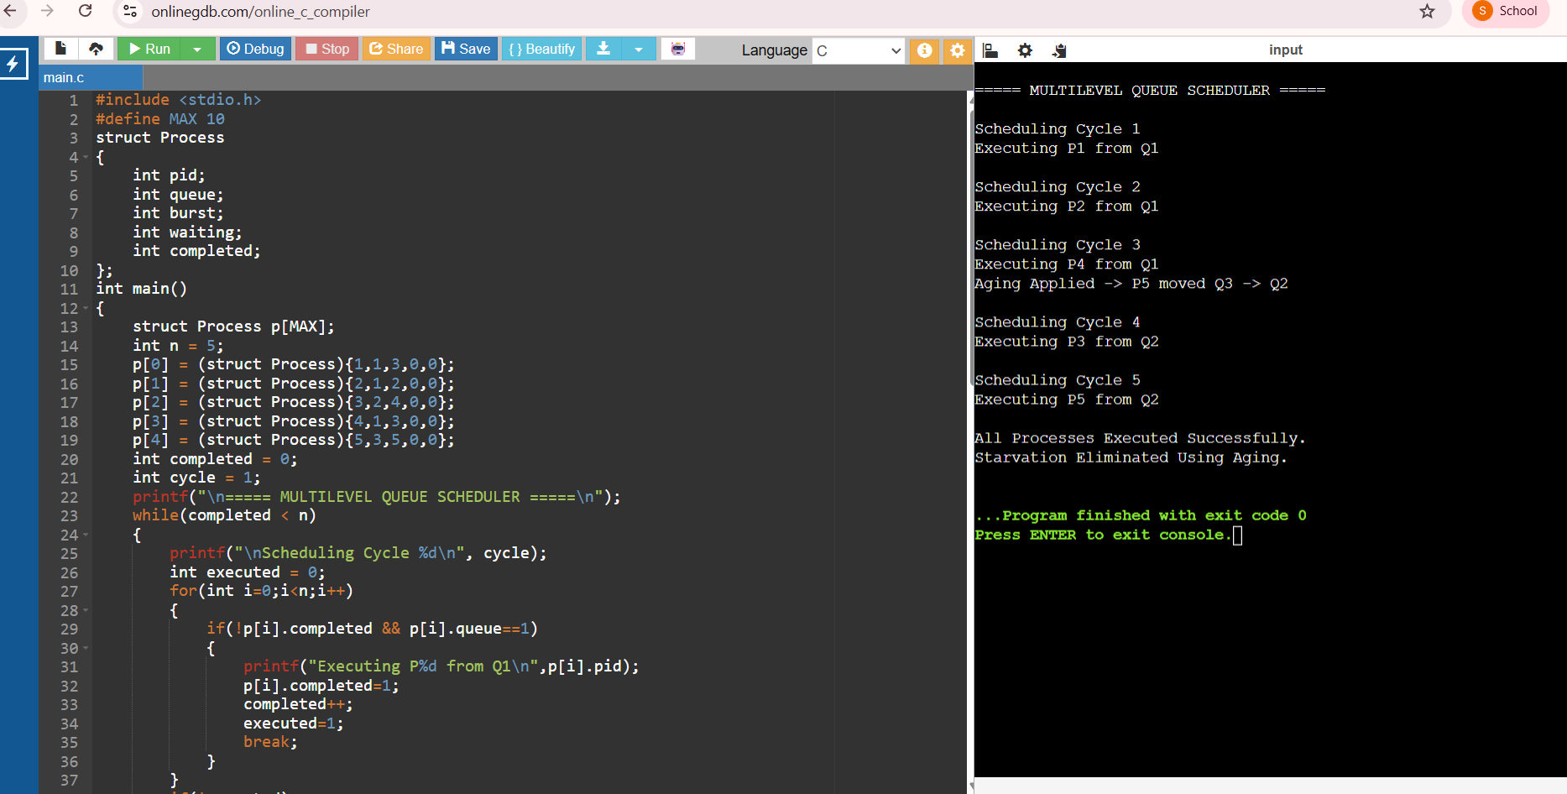
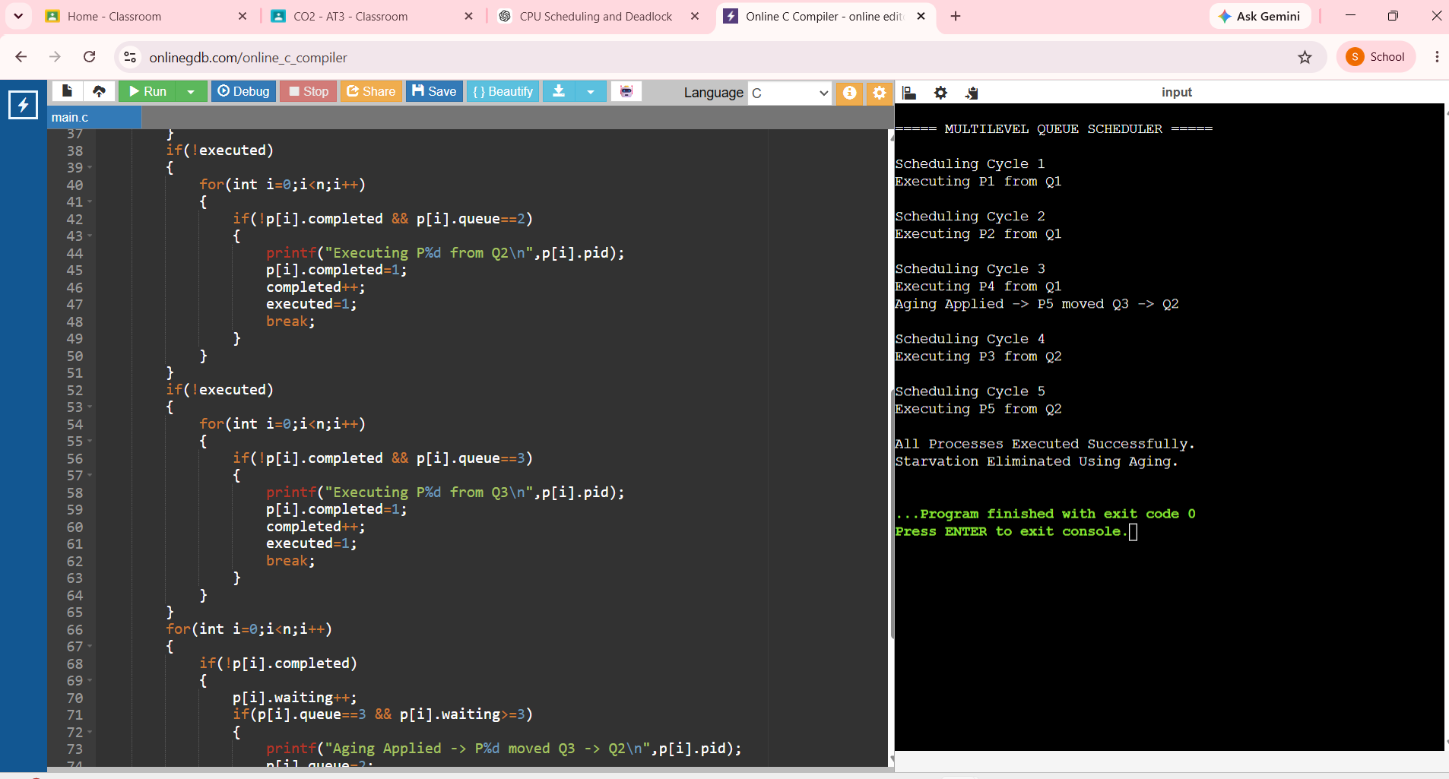
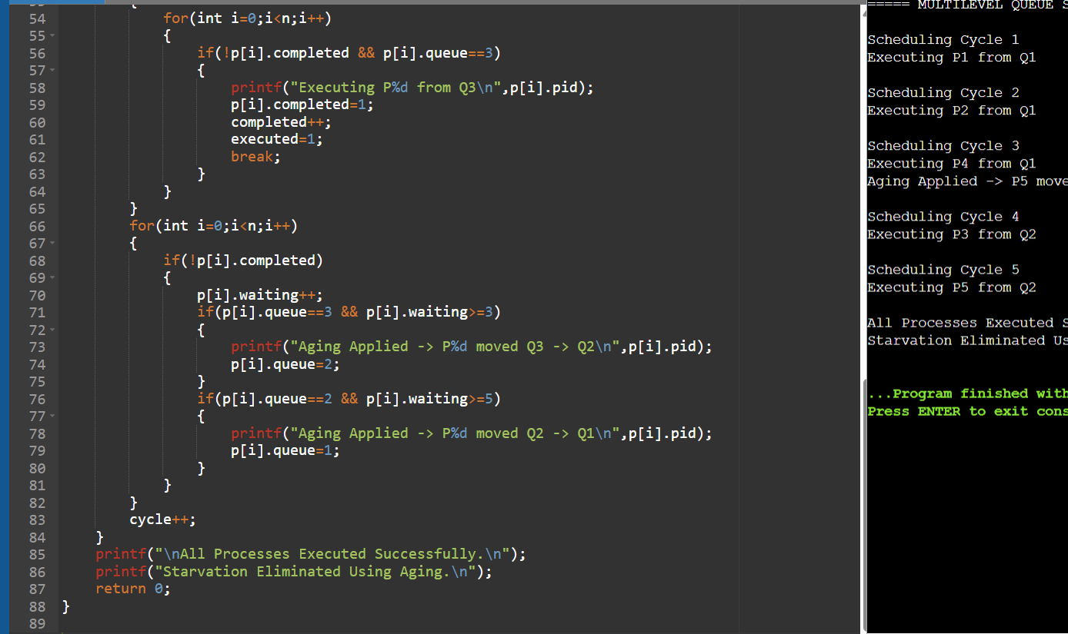
Q5. Context-Switch Overhead Debugging

#include <stdio.h>
int main()
{
int n, i;
printf("Enter number of processes: ");
scanf("%d",&n);
int bt[20], temp[20];
printf("\nEnter Burst Time of each process:\n");
for(i=0;i<n;i++)
{
printf("P%d : ",i+1);
scanf("%d",&bt[i]);
}
int quantum = 1;
int completed = 0;
int contextSwitch = 0;
for(i=0;i<n;i++)
temp[i]=bt[i];
while(completed<n)
{
for(i=0;i<n;i++)
{
if(temp[i]>0)
{
if(temp[i]>quantum)
{
temp[i]-=quantum;
contextSwitch++;
}
else
{
temp[i]=0;
completed++;
contextSwitch++;
}
}
}
}
printf("\n========== BEFORE OPTIMIZATION ==========\n");
printf("Time Quantum : %d ms\n",quantum);
printf("Context Switches : %d\n",contextSwitch);
quantum=4;
completed=0;
contextSwitch=0;
for(i=0;i<n;i++)
temp[i]=bt[i];
while(completed<n)
{
for(i=0;i<n;i++)
{
if(temp[i]>0)
{
if(temp[i]>quantum)
{
temp[i]-=quantum;
contextSwitch++;
}
else
{
temp[i]=0;
completed++;
contextSwitch++;
}
}
}
}
printf("\n========== AFTER OPTIMIZATION ==========\n");
printf("Time Quantum : %d ms\n",quantum);
printf("Context Switches : %d\n",contextSwitch);
if(contextSwitch<20)
printf("\nOptimization Successful.");
else
printf("\nContext Switching Still High.");
return 0;
}
OUTPUT:
Enter number of processes: 6

Enter Burst Time of each process:
P1 : 4
P2 : 6
P3 : 8
P4 : 2
P5 : 9
P6 : 7

========== BEFORE OPTIMIZATION ==========
Time Quantum : 1 ms
Context Switches : 36

========== AFTER OPTIMIZATION ==========
Time Quantum : 4 ms
Context Switches : 11

Optimization Successful.

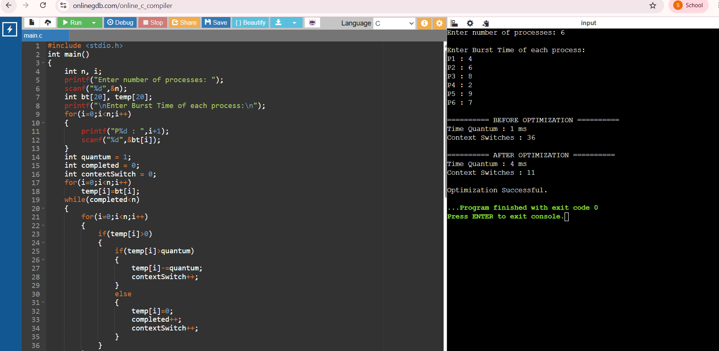
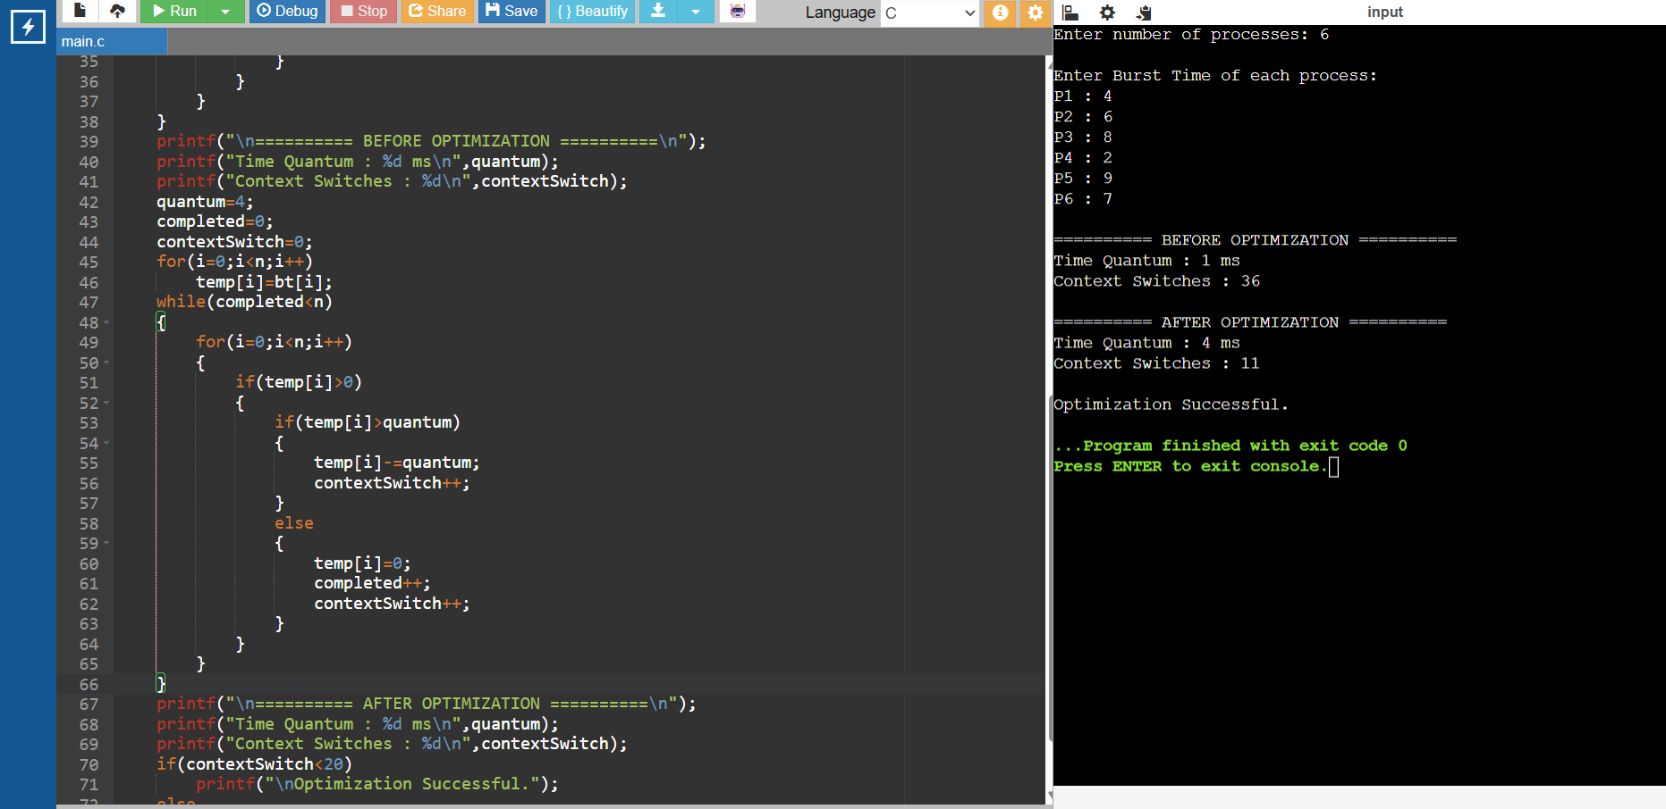

Rubrics for Calculation

Criteria | Weightage | Level 4 (Exemplary) | Level 3 (Proficient) | Level 2 (Developing) | Level 1 (Beginning)
Problem Identification | 20% | Accurately identifies all errors and root causes with clear understanding | Identifies most errors with minor gaps | Identifies some errors but misses key issues | Unable to identify errors correctly
Debugging | 25% | Applies systematic debugging techniques effectively to resolve issues | Uses appropriate debugging methods with minor errors | Limited debugging approach; requires guidance | Unable to debug or resolve issues
Optimization | 20% | Optimizes code by significantly improving time complexity using efficient algorithms | Improves time complexity with minor gaps in efficiency | Limited improvement in time complexity | No improvement; inefficient approach retained
Analysis | 20% | Demonstrates strong logical reasoning and clear justification of solutions | Shows reasonable analysis with some justification | Limited analysis; weak reasoning | No analytical reasoning demonstrated
Code Quality | 15% | Produces clean, well-structured code with proper comments and documentation | Code is mostly clear with minor documentation gaps | Code lacks structure and proper documentation | Poorly written code with no documentation

